

JTI
Trade Marketing Excellence Programme

Deletion of Contract Entity on OLTP

DOCUMENT HISTORY
Title
Deletion of Contract Entity on OLTP

REVIEWS
NAME | DATE | SIGNATURE
Virish Seechurn | 14/04/2015 | VS

APPROVALS
NAME | DATE | SIGNATURE

VERSION HISTORY
VERSION | EFFECTIVE  DATE | SUMMARY OF CHANGES | WRITTEN BY | STATUS
0.1 |  |  | Santanoo Ramjug | Closed
0.2 | 4/8/2015 | Review and Modify deletion documentation | Riteswaree Seewooruttun | Closed
0.2 | 14/04/2015 | Review | Virish Seechurn | Closed
0.3 | 30/11/2017 | Generic Script added for backups of impacted table & new trick for segment batch added as per INC2137136 | Misa Cyprienna | Closed
0.4 | 25-01-2018 | Updated Screenshots | Riteswaree Seewooruttun | Closed
0.5 | 29-01-2018 | Updated Backup tables and scripts + Review | Santanoo Ramjug | Open

DISTRIBUTION HISTORY
VERSION | COPY | ISSUED TO | DATE | ACTION REQUIRED

1. Introduction

This document gives the high-level description of the steps required for the deletions of Contracts entity data in Siebel OLTP (on S_DOC_AGREE table).

The main table for the contracts entity is S_DOC_AGREE table as shown below. This is identified by the * from the EIM mapping extract for the EIM_AGREEMENT table (the interface table for Contracts deletions).

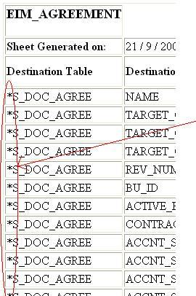

For contracts deletion, we perform the deletion on the S_DOC_AGREE table via EIM.

2. Performing backups before deletion

2.1 Script to back up the contract table and child tables impacted:

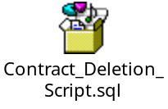

3. Populating EIM table for deletion

The user keys required for S_DOC_AGREE deletion are NAME, TARGET_OU_ID, REV_NUM and BU_ID as shown below:

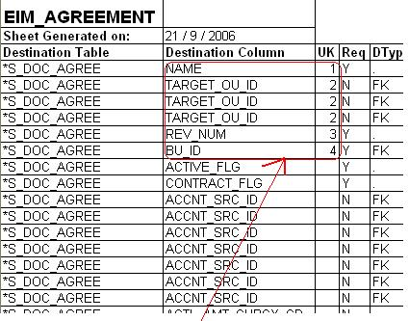

The following script is used to insert data into the EIM table for deletion: -

- Perform cleansing of EIM batch

DELETE FROM EIM_AGREEMENT
WHERE IF_ROW_BATCH_NUM BETWEEN 800000 AND 800999

- Populate EIM table with reference of records to be deleted

INSERT INTO EIM_AGREEMENT
(ROW_ID, IF_ROW_BATCH_NUM,IF_ROW_STAT,
AGR_NAME,
TARGET_ACCNT_BU, TARGET_ACCNT_LOC,TARGET_ACCNT_NAME,
AGR_REV_NUM,
AGR_BU
)
SELECT S_DOC_AGREE.ROW_ID, 800000+ ROW_NUMBER() OVER (ORDER BY S_DOC_AGREE.ROW_ID)/1000, 'FOR_DELETE',
S_DOC_AGREE.NAME,
B.NAME,
S_ORG_EXT.LOC, S_ORG_EXT.NAME, S_DOC_AGREE.REV_NUM,
A.NAME
FROM S_DOC_AGREE
LEFT OUTER JOIN S_ORG_EXT ON S_DOC_AGREE.TARGET_OU_ID=S_ORG_EXT.ROW_ID
INNER JOIN S_BU A ON A.ROW_ID = S_DOC_AGREE.BU_ID
LEFT OUTER JOIN S_BU B ON B.ROW_ID = S_ORG_EXT.BU_ID
WHERE S_DOC_AGREE.ROW_ID IN
(SELECT ROW_ID FROM StagingDB.dbo.CO_TO_BE_DELETED)

- Check EIM table

SELECT IF_ROW_BATCH_NUM, IF_ROW_STAT, COUNT(1)
FROM EIM_AGREEMENT(NOLOCK)
WHERE IF_ROW_BATCH_NUM BETWEEN 800000 AND 800999
GROUP BY IF_ROW_BATCH_NUM, IF_ROW_STAT
ORDER BY 1

4. Launching the deletion

The following ifb needs to be launched on the Sales Application to perform deletion. Before launching the ifb perform the following:
- Check correct transaction logging in ifb
- Batch range in ifb
- Place the ifb on the ADMIN folder for the corresponding environment

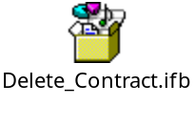

Follow the steps below to launch the ifb:

1. Log into the Sales Application on the corresponding environment
2. Click on the site map icon
3. Click on Administration - Server Management
4. Click on jobs under Administration - Server Management
5. Launch the ifb with the parameters shown below:

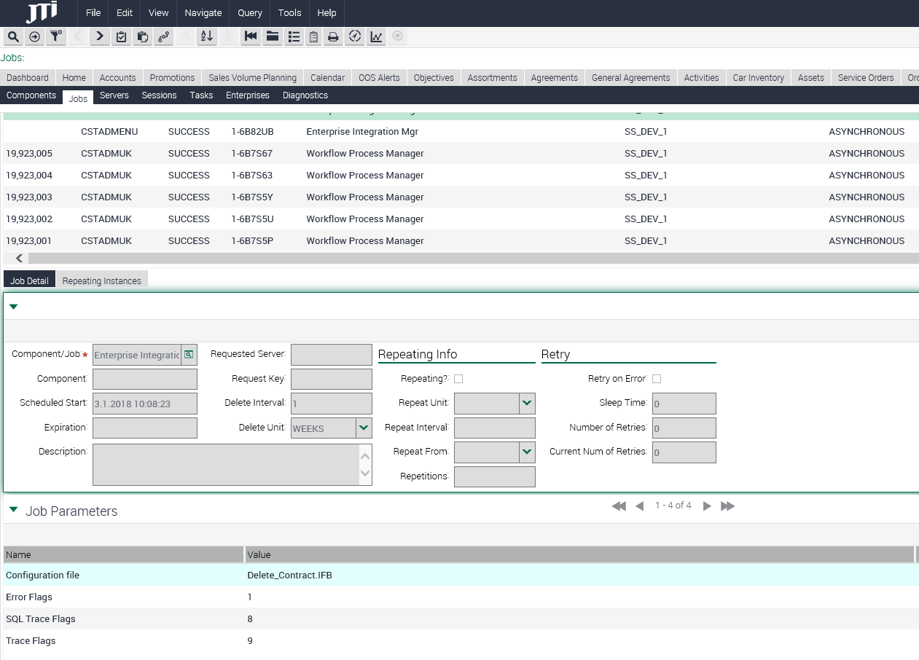

5. Monitoring the deletion operation & final check

Use the following query to monitor the status on the deletion:

SELECT IF_ROW_BATCH_NUM, IF_ROW_STAT, COUNT (1)
FROM EIM_AGREEMENT
WHERE IF_ROW_BATCH_NUM BETWEEN 800000 AND 800999
GROUP BY IF_ROW_BATCH_NUM, IF_ROW_STAT
ORDER BY IF_ROW_BATCH_NUM

The Status of IF_ROW_STAT should be ‘DELETED’. If any other status is obtained, then investigation is required (See next section).

Debugging the Delete Operation & Typical issues Encountered

If the status of the deletion on the EIM table is not correct, then go to the corresponding EIM process log folder and search for the EIM process log. Go through the log and search for errors reported. If the error log does not give any idea about the issue, then increase the log level of the EIM process to 1,8,9 instead of 1,2,1.

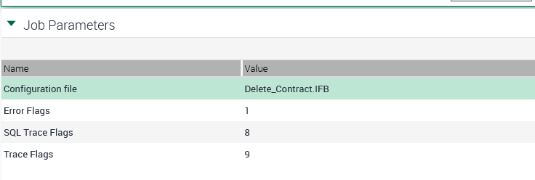

The common problematic IF_ROW_STAT obtained are:

- NO_SUCH_RECORD

This status is obtained when the process is not able to find the user keys provided in the EIM table. Check the user keys populated to ensure they are the correct ones.

- AMBIGUOUS

This status is obtained when the process finds the user keys provided more than once. In this case, the process gets confused to delete which record. Check for duplicate user keys and try to eliminate them.

6. Checking delete operation in database

Use the following query to check if the deletion has been correctly done on DB level:

SELECT *
FROM S_DOC_AGREE
WHERE ROW_ID IN (SELECT ROW_ID FROM StagingDB.dbo.CO_TO_BE_DELETED)

No record should be returned.

7. Checking delete in Siebel Application

Take a few sample ROW_ID’s from the backup table using the query below and query them on the Sales Application on Agreements screen. No records should be returned by the Sales Application query.

SELECT ROW_ID from StagingDB.dbo.S_DOC_AGREE_INCXXXXX_YYYMMDD

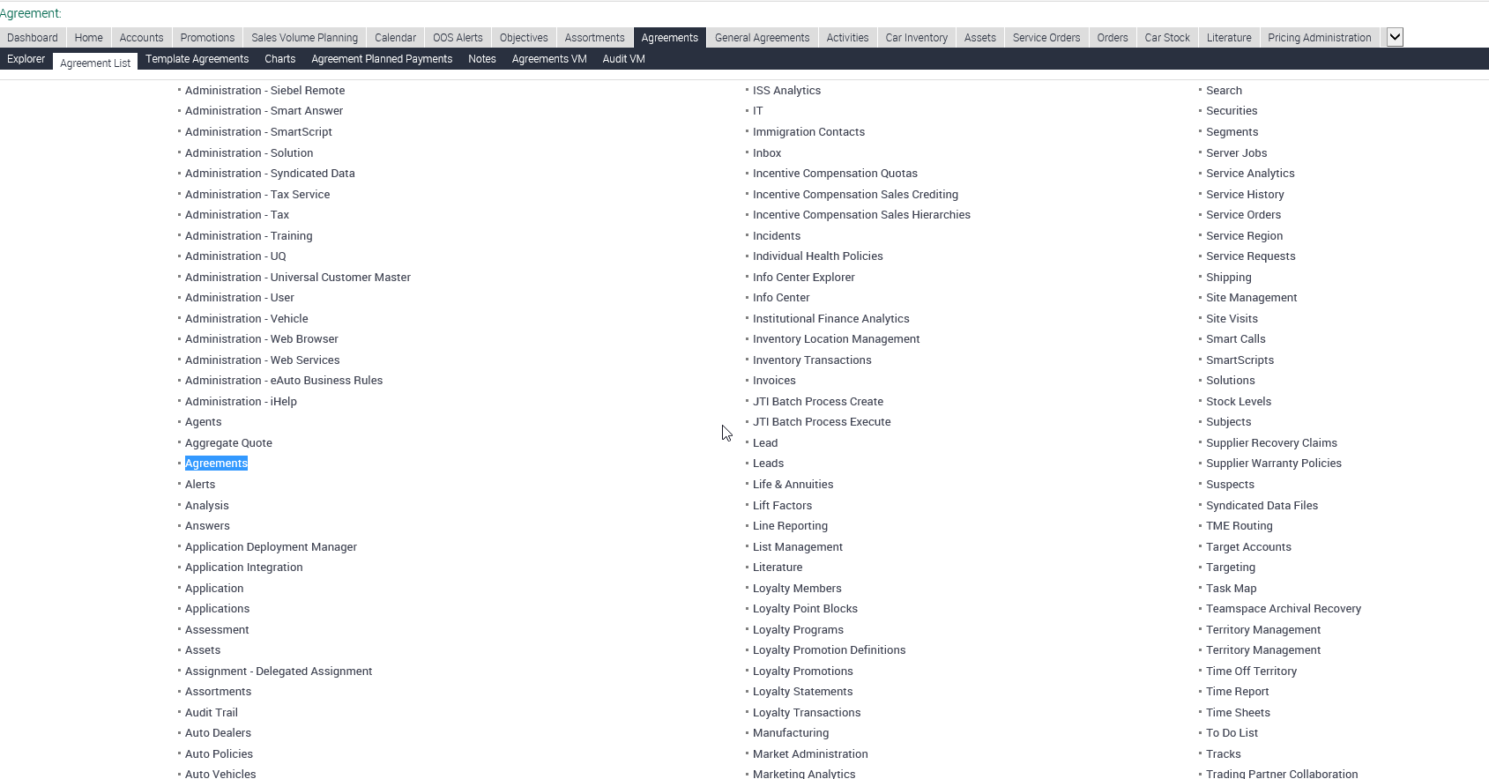

Query on the application using [Id] ='1-12ABN' -- replace with ROW_ID retrieved above.

